

INCLUDED

Promoting Inclusive Employment in the GLAM Sector through Open Innovation

(Module 1 – The digital GLAM-sector)

(SESSION 5)
(Developed by: SYNTHESIS)

This project n° 2022-1-AT01-KA220-ADU-00008513 has been funded by the European Union. Views and opinions expressed are however those of the author(s) only and do not necessarily reflect those of the European Union or OeAD-GmbH. Neither the European Union nor the granting authority can be held responsible for them.

Session 4 (four) - Face to Face Learning
Aims of the session:
- Learners know how to use all the different aspects on digital communication and collaboration learned in the previous sessions.
- Learners are able to plan, implement, and evaluate their own strategies on digital communication and collaboration in a professional environment.
Learning outcomes:
- On completion of these tasks, it is expected that learners can combine the learning outcomes of all sessions done in this module.
- On completion of these tasks, it is expected that learners can use digital tools for communication and collaboration in their respective professional environment in the GLAM sector.
- On completion of these tasks, it is expected that learners can reflect their own behaviour and those of others acting in digital communication and collaboration.
In this session learners will practice, implement, and reflect digital communication and collaboration in all its different aspects. It aims at consolidating and deepening existing theoretical knowledge and practical skills.

Description of the Learning Activities | Duration (minutes) | Materials and Equipment Required | Handouts/Activity Sheets
Part 1. Digital Communications strategy  This activity aims at combining all the skills and knowledge from the previous sessions.  Scenario:  All learners are part of the communication team in a GLAM institution. It's recommended that the trainer chooses an existing one from the local environment (e.g., local library, museum, gallery).  The trainer reminds participants that four digital skill development areas—those are needed throughout the industry and have the potential to have the biggest impact—have been selected by The Heritage Digital consortium.  Digital Marketing Strategy, Digital Communications, Digital Rights, and Digital Technology are the four areas.  The team in groups will concentrate on digital communications and a strategy for increasing accessibility at their institution. This will involve a virtual exhibition of the featured artists with impairments as well as a campaign to raise awareness for artists who have been classified as neurodivergent or disabled.  Resources:  https://d13kjxnqnhcmn2.cloudfront.net/AcuCustom/Sitename/DAM/042/Heritage_Digital_-_A_guide_to_growing_and_engaging_audiences.pdf  Task 1: Define roles and activities (5 minutes)  In a short meeting, each learner should choose a certain role in the team.  - Team leader:  There will be just one leader who will be in charge of organizing everything, establishing ground rules, and creating the necessary Canva channels for collaboration and communication. Additionally, S/He needs to be included in all upcoming duties.  - Online community managers:  These learners are responsible for developing a social media campaign for promoting the work of artists with disabilities and for reaching and activating as many visitors as possible in a virtual team. The campaign should be planned for 2 months (2 posts per week at least).  Resource: https://d13kjxnqnhcmn2.cloudfront.net/AcuCustom/Sitename/DAM/041/Heritage_Digital_Introduction_Guide.pdf  Task 2: Kick-off meeting (15-20 minutes)  The purpose of this brief in-person meeting is to establish and clarify the fundamental tenets of the online exhibit and its narrative storytelling approach. Goals, tactics, target audiences, etc. are required.  Task 3: Working phase (50 minutes)  Following the in-person meeting, the team members divide up into several rooms to use Canva to develop and carry out the social media awareness campaign.  In addition to preparing papers that must be uploaded to Google Drive, they will also need to set up a video conference. Finally, much as they did in this module's fourth session, the team needs to develop a social media plan. This time, they can use the template here proposed by Backlinko https://backlinko.com/templates/marketing/social-media-strategy  After this step, take a short break | 85 minutes  (15 minutes) | Pens and note taking materials  Laptops or mobile devices + Wi-Fi  Different rooms or quiet workplaces | Flipchart or whiteboard  Script on session 5 for taking notes
Part 2. Evaluation meeting  Once more, this meeting will take place in a single room, with the trainer taking on the role of the particular institution's CEO.  Task 1: Presentation (10 minutes)  The team leader discusses the planned event, target groups, goals, and specific actions on social media in addition to presenting the results utilising the detailed resources on Google Drive.  Task 2: Evaluation: (10 minutes)  The team assesses the elaborated findings and works to make them better, with the trainer serving as the CEO. The module and this session come to an end with a last round of lessons learned discussion. | 20 minutes | Video Beamer  Whiteboard or Flipchart | Script on session 4
Total duration of the session | 2 hours




INCLUDED
Promoting Inclusive Employment
in the GLAM Sector
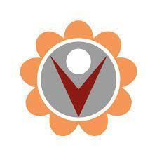
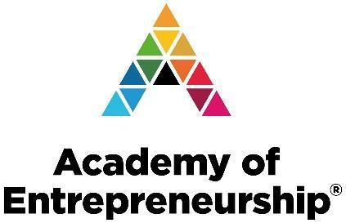
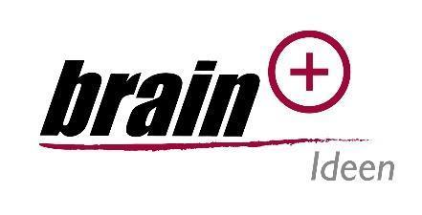
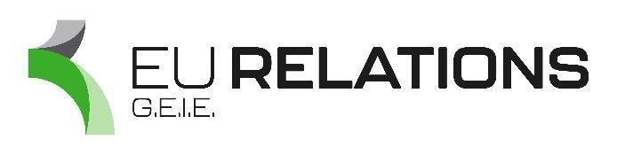
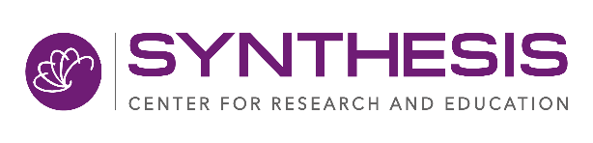
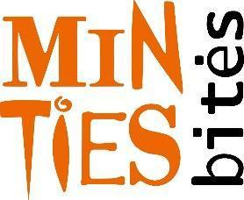
through Open Innovation

