

INCLUDED

Promoting Inclusive Employment in the GLAM Sector through Open Innovation

(MODULE 1 Digital Transformation Post-COVID in the GLAM Sector)

(SESSION 4)
(Developed by: SYNTHESIS)

This project n° 2022-1-AT01-KA220-ADU-00008513 has been funded by the European Union. Views and opinions expressed are however those of the author(s) only and do not necessarily reflect those of the European Union or OeAD-GmbH. Neither the European Union nor the granting authority can be held responsible for them.

Session 1 (length) - Face to Face Learning
Aims of the session:
- Examine the shifts in the GLAM sector post-COVID
- Familiarise learners with the dynamic future roles in the GLAM sector
- Encourage strategic thinking regarding digital transformation in cultural institutions.

Learning outcomes:
- Outline key shifts in the GLAM sector post-COVID.
- Recall new job roles in the GLAM sector.
- Utilise strategic thinking for dealing with digital transformation in cultural institutions.
In this session, the learner will gain a basic understanding of the shift to digital for the GLAM sector post-COVID and the dynamic roles derived from this digital transition. At the same time, the learner will have the opportunity to delve into more strategic thinking regarding digital transformation in cultural institutions.

Description of the Learning Activities | Duration (minutes) | Materials and Equipment Required | Handouts/Activity Sheets
Part 1. Repetition of theoretical aspects  The trainer starts the session by using the attached PowerPoint presentation on slides 2 and 3. The following reflective questions are asked at the end of the online part of this session and again to start the classroom session.  What is digital transformation?  What are some of the emerging job roles for GLAM professionals post-COVID?  The learners can check their notes or open the online part of this session again to remember these terms and to get prepared for the following content. | 15 minutes | Pens and note-taking materials  Beamer  Flipchart or whiteboard for the trainer to take notes | PowerPoint Presentation of online session 4 (if needed)
Part 2.  The trainer asks the learners to watch the video from a Video series for the Museums in Context course of the MA Cultural Economics and Entrepreneurship Program at the Erasmus University Rotterdam. Then, follows a brief recap and discussion. Learners with the help of the trainer, take notes of the following:  - How can museums benefit from digital innovation?  - Why are less than half of the world’s collections online?  Activity:  The trainer asks the learners to work in groups of two and experiment with 3D pottery.  https://artsandculture.google.com/experiment/3d-pottery/nwHg1D0riJ1ltA | 30 minutes | Laptops and Internet connection  Flipchart or whiteboard for the trainer to take notes  Pens and note-taking materials | PowerPoint Presentation  page 4
Part 3. Digital collections and the online experience  The trainer reminds the learners of the part of the online session discussing Europeana, which is Europe’s platform for digital collections, preservation and sustainability.  The trainer then refers the learners to the new role of digital collections curator, which was mentioned in the online part of session 4.  Activity:  The trainer asks the learners to go to Europeana collections and scroll the page for a few minutes. They need to jog down their answers to these questions:  See how the page is built under different categories.  Do you think the platform is accessible to diverse learners?  Are the categories appropriate for the user to retrieve the collections?  How is visiting a digital collection different from going to a physical museum? | 20 minutes | Laptops and Internet connection  Flipchart or whiteboard for the trainer to take notes  Pens and note-taking materials | PowerPoint Presentation  page 7
Part 4. Digital Social Media in GLAM  The trainer refers the learners to the new role of online community manager, which was mentioned in the online part of session 4.  Activity:  The trainer explains that the group will engage in role play and take up the role of an online community manager. In this respect, the trainer presents a template and guide developed by Heritage Digital, and goes through the document in brief with the learners, so as to complete the following:  Why is a social media Policy necessary?  Add details of the organisation (learners decide between an imaginary GLAM institution)  Scope and purpose of the policy  Guidelines on the use of social media by staff  Protecting and safeguarding when using social media  and adhering to the policy.  Heritage_Digital_Social_Media_Policy_2.docx | 40 minutes | Laptops and Internet connection  Flipchart or whiteboard for the trainer to take notes  Pens and note-taking materials  https://docs.google.com/document/d/15sigmjFi0f6RQItrD9HzXXlS8k0nWdH5/edit?usp=sharing&ouid=102304553701014768146&rtpof=true&sd=true | PowerPoint Presentation  page 11  PowerPoint Presentation of online session 4 (if needed)
Close of Session 1  Self reflective session. The trainer asks from the learners to consider the following:  What are digital collections and what is the relevant job role/profile?  Do you think that going digital has potential to make GLAM institutions more accessible? | 15 minutes | Laptops and Internet connection  Flipchart or whiteboard for the trainer to take notes  Pens and note-taking materials | PowerPoint Presentation  page
Total duration of the session | 2 hours




INCLUDED
Promoting Inclusive Employment
in the GLAM Sector

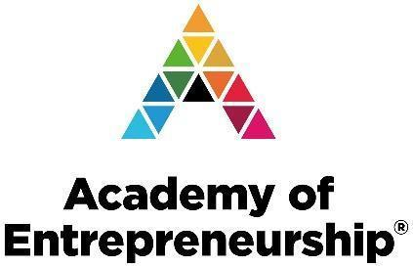
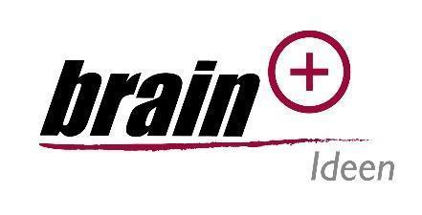
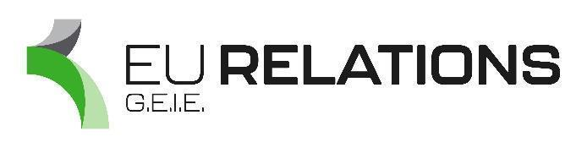

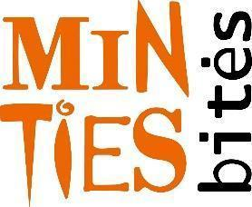
through Open Innovation

