

INCLUDED

Promoting Inclusive Employment in the GLAM Sector through Open Innovation

MODULE 1- THE DIGITAL GLAM-SECTOR

SESSION 2: BEING DIGITAL IN THE GLAM SECTOR
(Developed by: SYNTHESIS Centre of Research and Education CYPRUS )

This project n° 2022-1-AT01-KA220-ADU-00008513 has been funded by the European Union. Views and opinions expressed are however those of the author(s) only and do not necessarily reflect those of the European Union or OeAD-GmbH. Neither the European Union nor the granting authority can be held responsible for them.

Session 1 (length) - Face to Face Learning
Aims of the session:
- Explore the transformative impact of digital technologies on cultural institutions.
- Highlight the importance of being digitally proficient for success in GLAM sectors.
- Provide Examples of Good Practices for modelling and reflection.
Learning outcomes:
- Understand how digitalization has transformed cultural institutions.
- Acquire knowledge on tools and strategies on how to apply digital transformation on cultural institutions.
- Gain a holistic understanding of contemporary skills need to thrive to GLAM roles.
In this session learner will explore the transformative impact of digital technologies on cultural institutions, emphasizing the importance of technological adaptation. Through case studies and examples of good practices, learner will acquire up-to-date insights about digitalization's reshaping and innovative tools for digital transformation. They also gain a deep understanding on the importance of contemporary digital strategies and approaches for thriving in GLAM roles.

Description of the Learning Activities | Duration (minutes) | Materials and Equipment Required | Handouts/Activity Sheets
Part 1. The Trainer begins the session with highlighting to the learners the importance of Digital Transformation in the cultural sectors. The Trainer will present the online part of the training and will write the main points of the presentation on a flipchart or whiteboard, they will encourage learners to copy them in their personal notebooks but also let them know that the full presentation will be sent to them. | 15 minutes | Laptop or device with internet access  Presentation slides  Projector and screen  Pens and note-taking materials  Flipchart or whiteboard for the trainer to take notes | x
Part 2. The Trainer asks the trainees to speculate “How covid19 pandemic and lockdown affected the cultural sectors?”. Elicit their answers and come to the conclusion that the pandemic, lockdown and social distancing, ushered the cultural institutions and GLAM sector in general to adopt new technologies and digitalisation in order to safeguard their surviving and offer to the public the chance to still visit/interact with culture and arts.  - Elicit a list of examples (museums, music concerts, art exhibitions – galleries, theatre) – the Trainer should write those on the flipchart/whiteboard.  - Activity 1: Ask the participants to take pen & paper and write down a list of benefits of incorporating digital tools and options to the GLAM sector. Allow them 10 minutes to write down their list. After 10 minutes pass ask the participants to share what they wrote (some or all points) and then facilitate a discussion amongst all of them. | 15 minutes | Laptop or device with internet access  Presentation slides  Projector and screen  Pens and note-taking materials  Flipchart or whiteboard for the trainer to take notes | x
Part 3. The Trainer opens this part-activity by sharing that: “ Our objective for this part of the session is to explore the impact of the COVID-19 pandemic on living heritage and discover how communities have shown resilience, solidarity, and inspiration during these challenging times through the exchange of experiences.”  Step 1: Outline UNESCO's initiative to gather experiences related to intangible cultural heritage during the pandemic.  Step 2: Play the UNESCO video linked above, showcasing outcomes and experiences related to intangible cultural heritage during the COVID-19 pandemic. Encourage trainees to pay attention to the different ways living heritage has been affected and how communities have responded.  UNESCO video link: https://www.youtube.com/watch?v=vVp8-oj_RqU (Duration: 01:27 minutes)  Step 3: Group Discussion. Divide the trainees into small groups and facilitate a discussion on the following questions:  - How has the COVID-19 pandemic affected intangible cultural heritage in your community or region?  - Have you witnessed any examples of resilience, solidarity, or inspiration related to living heritage during the pandemic?  - What lessons can we learn from these experiences, and how can they be applied to future challenges?  Step 4: Encourage participants to share personal anecdotes, observations, or insights.  - Invite each group to share key points from their discussions with the larger group.  - Encourage open dialogue and exchange of perspectives among all participants.  Step 5: Reflection and closing. Summarize the main takeaways from the workshop, emphasizing the importance of preserving and promoting intangible cultural heritage. | 30 minutes | Laptop or device with internet access  Presentation slides  Projector and screen  Pens and note-taking materials  Flipchart or whiteboard for the trainer to take notes
Part 4. The Trainer will initiate this part by highlighting how many museums around the world have offered virtual tours, especially during periods of closures or restrictions due to events like the COVID-19 pandemic.  There are several reasons why museums choose to offer virtual tours:  - Accessibility: Virtual tours make museums accessible to a global audience. People who might not have the opportunity to visit the museum in person due to geographical or mobility constraints can still experience its exhibits and collections online.  - Education: Virtual tours provide educational opportunities for students, teachers, and lifelong learners. Schools and educational institutions can incorporate virtual museum visits into their curriculum, allowing students to explore artworks, historical artifacts, and scientific exhibits from anywhere with an internet connection.  - Promotion and Outreach: Virtual tours serve as a promotional tool for museums, attracting visitors and generating interest in their collections and exhibitions. They also help museums maintain their visibility and relevance during times when physical visits may not be possible.  - Cultural Preservation: Virtual tours contribute to the preservation of cultural heritage by digitizing and sharing museum collections. This digital preservation ensures that artworks and artifacts can be accessed and appreciated by future generations, even if the originals are fragile or inaccessible.  - Innovation and Adaptation: Offering virtual tours demonstrates a museum's ability to innovate and adapt to changing circumstances. It shows a willingness to embrace technology to enhance visitor experiences and stay connected with the public, even during challenging times.  Overall, virtual tours have become an important component of museum operations, providing opportunities for engagement, learning, and cultural exchange in the digital age.  The Trainer will provide some examples and good practices of the digitalisation in Museums/Galleries.  Activity 2:  Step 1: Ask the participant to visit – browse through and write down notes and impressions (10 minutes)  - Pergamon Museum, Berlin: https://rb.gy/vxamm0  - Van Gogh Museum, Amsterdam:  https://rb.gy/hwn1pg  - Uffizi Gallery, Florence:  https://rb.gy/cgwn2j  Step 2: Elicit a conversation/reflection amongst participants. You can use the questions provided below:  - What did you like the most from the virtual tours?  - What could be improved based on your observations?  - Will you utilise these features again in the future?  - Would you recommend it to other people? And if yes who and why? (for example, groups of people like disabled individuals, individuals with social anxiety, people in vulnerable health-wise state, etc.) | 45 minutes | Pens and note-taking materials  Flipchart or whiteboard for the trainer to take notes  Laptops and Internet connection | x
Close of Session 1 At the end of this session, the trainer gives general feedback to the whole team and allows some time for questions and discussion. | 15 minutes
Total duration of the session | 2 hours




INCLUDED
Promoting Inclusive Employment
in the GLAM Sector


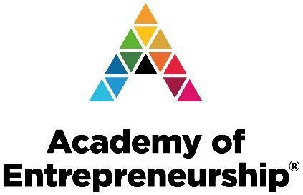
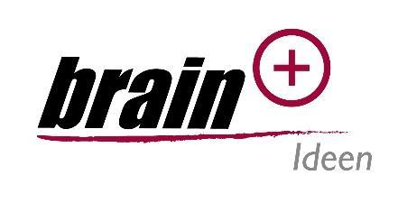

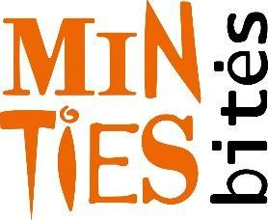
through Open Innovation

