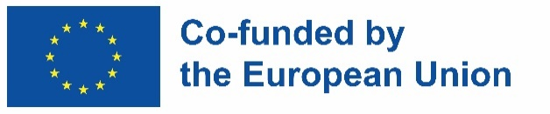

INCLUDED

Promoting Inclusive Employment in the GLAM Sector through Open Innovation

MODULE 4 - DIGITAL CONTENT CREATION SESSION 1 - INTRODUCTION TO DIGITAL CONTENT CREATION

HANDOUTS

This project n° 2022-1-AT01-KA220-ADU-00008513 has been funded by the European Union. Views and opinions expressed are however those of the author(s) only and do not necessarily reflect those of the European Union or OeAD-GmbH. Neither the European Union nor the granting authority can be held responsible for them.

Activity Sheet No. 1
The National Gallery will host, for a limited time, the famous painting 'Primavera'.
You are asked to create an article of 350-400 words with information about the painting. This article will be shared with the Gallery's audience at a later time, so you need to make sure that there are no spelling or grammar mistakes.

Scheda attività n. 2
Ora che l'articolo è scritto manca ancora una cosa: una foto.
Ti viene chiesto di visitare https://www.canva.com/design/DAF6mZ7LRlQ/n4YxM074OuY4XzqNhpSnJQ/edit e modificare il modello. Sei libero di essere creativo e modificare i caratteri, le dimensioni dei caratteri e i colori del modello fornito. Dovrai inoltre aggiungere il nome della Biblioteca nell'apposita area del template.

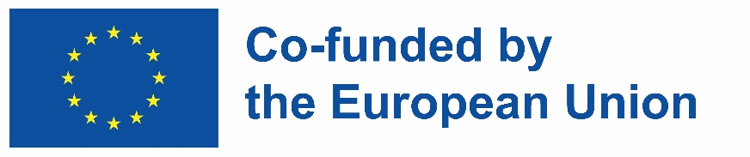


INCLUDED
Promoting Inclusive Employment
in the GLAM Sector
through Open Innovation


