

INCLUDED

Promoting Inclusive Employment in the GLAM Sector through Open Innovation

(MODULE 1 The digital GLAM-sector)

(SESSION 1)
(Developed by: SYNTHESIS)

This project n° 2022-1-AT01-KA220-ADU-00008513 has been funded by the European Union. Views and opinions expressed are however those of the author(s) only and do not necessarily reflect those of the European Union or OeAD-GmbH. Neither the European Union nor the granting authority can be held responsible for them.

Session 1 (length) - Face to Face Learning
Aims of the session:
- Understand foundational digital competencies required for the GLAM sector.
- Familiarise with digital skills required to work in the GLAM sector.
Learning outcomes:
- Discover foundational digital skills related to working in the GLAM sector.
- Define and recall key competences required for success in the GLAM sector.
In this session, the learner will gain a basic understanding of digital competencies required for GLAM professionals. At the same time, the learner will have the opportunity to familiarise with digital skills required to work in the GLAM sector.

Description of the Learning Activities | Duration (minutes) | Materials and Equipment Required | Handouts/Activity Sheets
Part 1. Repetition of theoretical aspects  The trainer starts the session by using the attached PowerPoint presentation on slides 2 and 3. The following reflective questions are asked at the end of the online part of this session and again to start the classroom session.  Why are digital skills important for GLAM?  What are some key areas of digital competencies required when working in the GLAM sector?  The learners can check their notes or open the online part of this session again to remember these terms and to get prepared for the following content. | 15 minutes | Pens and note-taking materials  Beamer  Flipchart or whiteboard for the trainer to take notes | PowerPoint Presentation of online session 1 (if needed)
Part 2. Digital work in the GLAM sector  The trainer asks the learners to watch the video about the digital reconstruction of Athena by The Museum of Fine Arts, in Boston. Then, follows a brief recap and discussion. Learners with the help of the trainer, take notes of the following:  - What is polychromy?  - What are the different steps for the digital reconstruction work for the sculpture of Athena and her true colors?  Activity:  The trainer asks the learners to work in groups of two and explore with the art of colour.  https://artsandculture.google.com/pocketgallery/IQUxrMnvNro2DQ | 30 minutes | Laptops and Internet connection  Flipchart or whiteboard for the trainer to take notes  Pens and note-taking materials | PowerPoint Presentation  page 4
Part 3. Areas of digital competencies in the GLAM sector  The trainer reminds the learners that there are three areas of digital competencies in the GLAM sector which are important.  - Information and data literacy  - Communication and collaboration  - Digital content creation  The learners can check their notes or open the online part of this session again to remember these terms and to get prepared for the following content.  The trainer then reminds the learners of the statements presented during the online session about some of the tasks related to digital skills when working in the GLAM sector. The trainer then asks the learners to match the statements with the areas of digital competencies.  Activity:  Can you match the statements with the areas of digital competencies?  - to understand and avoid risks associated with sensitive data - Information and data literacy  - to be familiar with basic behavioural norms in digital environments Communication and collaboration  - to be familiar with relevant policies, regulations and guidelines on data preservation and reuse, especially in the public sector - Information and data literacy  - to be able to check and understand the right to use and/or re-use digital content created by a third party - Digital content curation  - to be aware of accessibility requirements when communicating in digital environments so that communication is inclusive and accessible for all users - Communication and collaboration  - to understand fundamentals of digital preservation - Digital content curation | 20 minutes | Laptops and Internet connection  Flipchart or whiteboard for the trainer to take notes  Pens and note-taking materials | PowerPoint Presentation  page 7  PowerPoint Presentation of online session 1 (if needed)
Part 4. Digital marketing strategy  The trainer reminds of the four digital areas of improvement for the heritage sector presented also during the online session.  Digital communications  Digital marketing strategy  Digital rights  Digital tech  The intention in this part is to look specifically at digital marketing strategy and how it can serve neurodivergent people.  Trainer introduces key components of a digital marketing strategy and then refers to Heritage Digital’s guide for digital marketing strategy. The idea is to review the key components briefly:  Knowing your vision and mission  Evaluating where you are currently  Knowing where you want to get  Measuring your success  The trainer asks learners to look at page 8 of the guide referring to the target audience of the supposed GLAM institution and complete in the printed personas template, the details related to a target audience of people with disabilities, including neurodivergent people.  A discussion follows on the notes taken and the trainer records the summary on the whiteboard or flipchart.  What differentiates the digital marketing strategy when it comes to people with disabilities?  What should be taken into consideration? | 40 minutes | Laptops and Internet connection  Flipchart or whiteboard for the trainer to take notes  Pens and note-taking materials  page 8 of the guide here: https://d13kjxnqnhcmn2.cloudfront.net/AcuCustom/Sitename/DAM/051/HD_DMS_guide_final.pdf | PowerPoint Presentation  page 11
Close of Session 1  Self reflective session. The trainer asks from the learners to consider the following:  What digital skills do you feel more confident in from the ones mentioned today?  What would you like to improve in? | 15 minutes | Laptops and Internet connection  Flipchart or whiteboard for the trainer to take notes  Pens and note-taking materials | PowerPoint Presentation  page 13
Total duration of the session | 2 hours




INCLUDED
Promoting Inclusive Employment
in the GLAM Sector


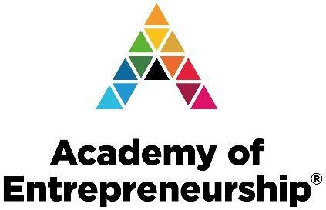
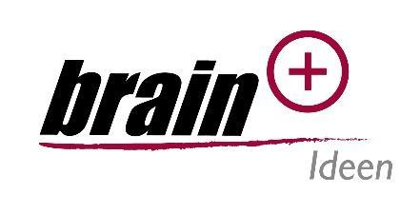

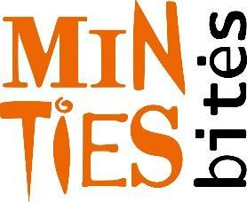
through Open Innovation

